**Supplementary text S1**

**Instructions for effortless awareness meditation**

“In today’s experiments, we will be studying effortless awareness. An example of this is noticing that hearing the sound of my voice does not require any special effort on your part. In contrast, if you were in an argument recently, it is easy to get caught up in emotions by reliving the situation in your head. The thoughts or situation aren’t the issue, but how you’re relating to them –being caught up in them. This is an example of not being effortlessly aware. Other examples include trying to control your thoughts or experience, or resisting or forcing something, or even getting caught up in fantasy or excitement. However you may find that it is also possible to simply observe any thoughts, emotions or bodily sensations that come up and not get caught up in or swept away by them. Can you see the contrast between the two –effortless awareness and being caught up in experience?”

*For experienced meditators only: “*Do you understand what I mean by effortless awareness or just resting in awareness? Others describe it differently. Can you describe what effortless awareness is like in your experience? What types of meditation or non-meditation practices do you do in which you are effortlessly aware? Do you think you can drop into this today? You can have your eyes open or closed, please do whatever is most natural and effortless for you. Which is most effortless for you, eyes open or eyes closed? Try practicing it for a moment now. How was that for you? It is important that you do not change your effortless awareness practice during the experiment. Near the end, there is time to play around with other kinds of practices. It is also important that do you do not change whether you meditate with eyes open or eyes closed. Please stick with what you chose.”

*For novice meditators only: “*If you haven’t had a lot of experience with just resting in effortless awareness, there can be some techniques that help point in that direction. One simple one is called noting practice, where you simply note what is most predominant in your experience from moment to moment. For example you just become aware of your senses, seeing, hearing, feeling, and thinking, and just note silently to yourself whatever is at the forefront of your awareness in any moment. For example I might note seeing because I’m looking at you, and then hearing because I’m hearing the sounds in the room, and then I notice my shoulders are tense so I’d note feeling, and then I start thinking that my shoulders are tense so I note thinking. The sequence would go seeing, hearing, feeling, feeling and so on. Whatever is most predominant in the moment, just note it. Does this make sense? I will provide an example (15 s, note approx.once per second). Try this now, just noting seeing, hearing, feeling and thinking for the next 30 seconds or so. And note out loud this time so I can follow you. Do you think you can do this during the EEG run, just silently noting your experience from moment to moment? Don’t worry about doing it perfectly, just do the best you can. If your mind wanders or you get caught up in something, no problem; when you become aware again, just start again by noting whatever is predominant. Please try practicing this now, silently noting your experience, seeing, hearing, feeling, and thinking, from moment to moment with your eyes open.”

**Supplementary text S2**

For step (ii-vi) after the last run of each step participants were asked: (1) “Across all experiments so far, do you think effortless awareness corresponds with the graph being upward or downward?” (2) “How confident are you that effortless awareness corresponds with that direction, from 0-10, with 0 being not at all, and 10 being perfectly?”

For step (iii) after each run, participants were asked: (3) “Does effortless awareness correspond with the graph being upward or downward?” (4) “How well does the graph correspond with your experience during effortless awareness and its opposite from 0-10, 0 being not at all, and 10 being perfectly?” After the last run, participants were asked questions (1) and (2).

**Supplementary tables S3-S7**

*Table S3. Number and percentage of experienced meditators who meditated with their eyes open and their eyes closed choosing decreased PCC activity to be associated with effortless awareness. P(corrected) indicates Bonferroni corrected P-values for all 13 analyses.*



*Table S4. Median confidence ratings of experienced meditators who meditated with their eyes open and their eyes closed choosing decreased PCC activity to correlate with effortless awareness. Min and max columns indicate minimum and maximum observed values. P(corrected) indicates Bonferroni corrected P-values for all 13 analyses.*



*Table S5. Median moment-to-moment correspondence ratings between PCC activity and subjective experience of effortless awareness for experienced meditators who meditated with their eyes open and their eyes closed. Min and max columns indicate minimum and maximum observed values. P(corrected) indicates Bonferroni corrected P-values for all 13 analyses.*



*Table S6. Percentage of time of decreased PCC activity vs baseline for experienced meditators who meditated with their eyes open and their eyes closed for the volitional control in the direction of effortless awareness runs (step v). Min and max columns indicate minimum and maximum observed values. P(corrected) indicates Bonferroni corrected P-values for all 13 analyses.*



*Table S7. Percentage of time of increased PCC activity vs baseline for experienced meditators who meditated with their eyes open and their eyes closed for the volitional control in the direction of effortless awareness runs (step vi). Min and max columns indicate minimum and maximum observed values. P(corrected) indicates Bonferroni corrected P-values for all 13 analyses.*



**Supplementary Table S8**

*Correlation coefficients between PCC activity and left temporalis muscle activity with associated P-values for each meditation with real-time neurofeedback run (step iii) and volitional manipulation in the direction of effortless awareness run (step v).*

PCC and left temporal muscle activity were considered to be significantly associated when at least 2 out of 3 runs for a participant showed a significant correlation in the same direction. The **(+)** and **(-)** symbols in the last 2 columns denote that this threshold was met with a positive or negative association for that subject, respectively. MRTNF = meditation with real-time neurofeedback, VC = volitional control (* p < 0.05, ** p < 0.005).

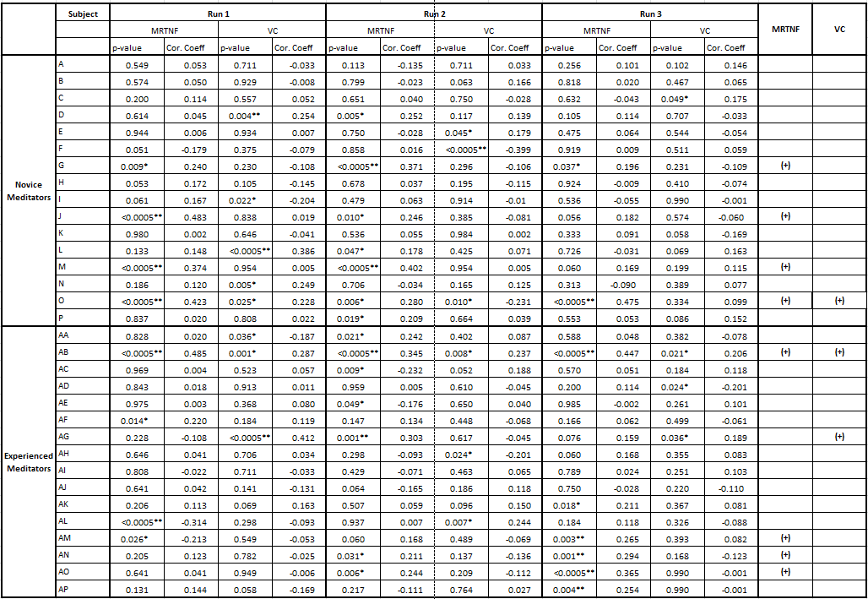

**Supplementary Table S9**

*Correlation coefficients between PCC activity and right temporalis muscle activity with associated P-values for each meditation with real-time neurofeedback run (step iii) and volitional manipulation in the direction of effortless awareness run (step v).*

PCC and right temporal muscle activity were considered to be significantly associated when at least 2 out of 3 runs for a participant showed a significant correlation in the same direction. The **(+)** and **(-)** symbols in the last 2 columns denote that this threshold was met with a positive or negative association for that subject, respectively. MRTNF = meditation with real-time neurofeedback, VC = volitional control (* p < 0.05, ** p < 0.005).

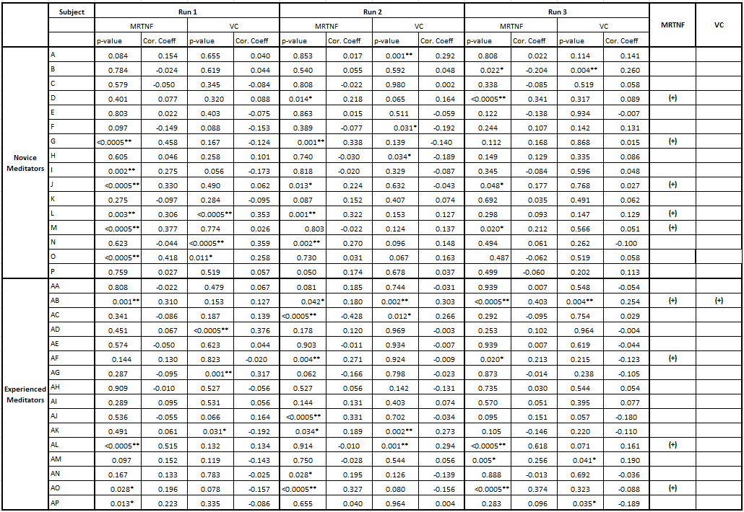

**Supplementary Table S10**

*Correlation coefficients between PCC activity and microsaccades with associated P-values for each meditation with real-time neurofeedback run (step iii) and volitional manipulation in the direction of effortless awareness run (step v).*

PCC and microsaccades were considered to be significantly associated when at least 2 out of 3 runs for a participant showed a significant correlation in the same direction. The **(+)** and **(-)** symbols in the last 2 columns denote that this threshold was met with a positive or negative association for that subject, respectively .MRTNF = meditation with real-time neurofeedback, VC = volitional control. For subjects D and AJ, data was not available due to equipment malfunctioning. (* p < 0.05, ** p < 0.005).

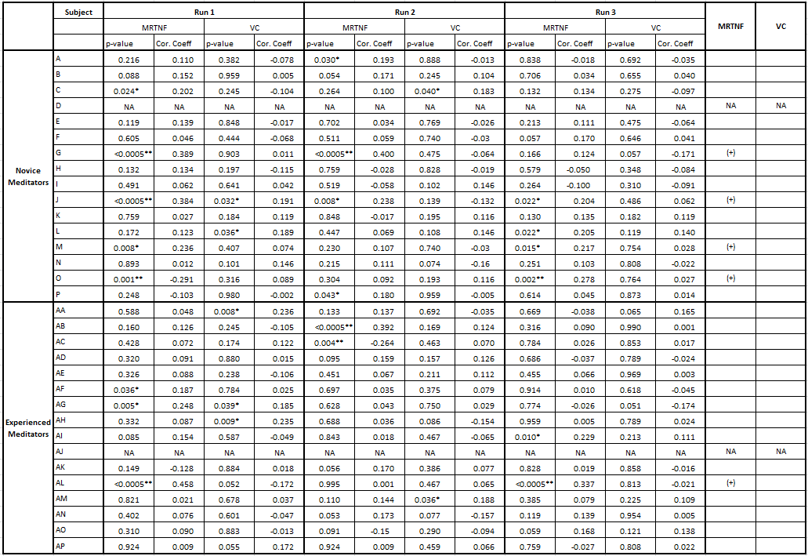

**Supplementary Table S11**

*Correlation coefficients between PCC activity and horizontal eye movements with associated P-values for each meditation with real-time neurofeedback run (step iii) and volitional manipulation in the direction of effortless awareness run (step v).*

PCC and horizontal eye movements were considered to be significantly associated when at least 2 out of 3 runs for a participant showed a significant correlation in the same direction. The **(+)** and **(-)** symbols in the last 2 columns denote that this threshold was met with a positive or negative association for that subject, respectively. MRTNF = meditation with real-time neurofeedback, VC = volitional control. For subjects D and AJ, data was not available due to equipment malfunctioning. a: No horizontal eye-movements present in run. (* p < 0.05, ** p < 0.005).

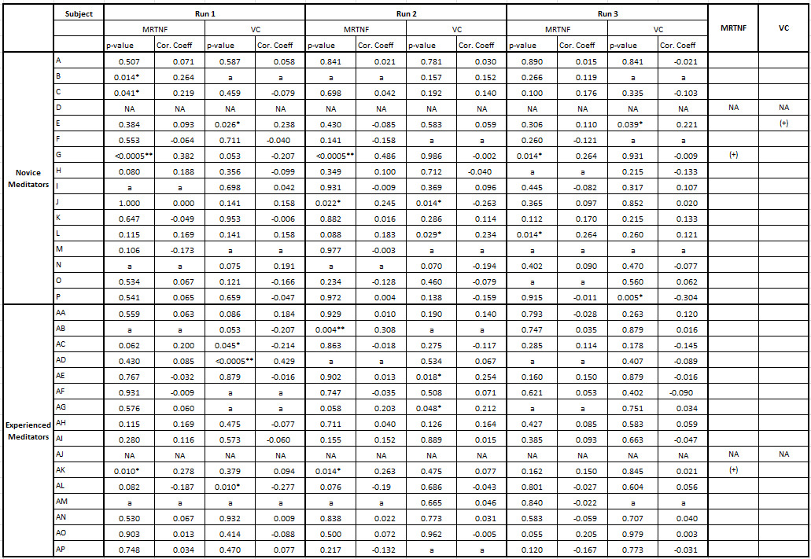

**Supplementary Table S12**

*Correlation coefficients between PCC activity and vertical eye movements with associated P-values for each meditation with real-time neurofeedback run (step iii) and volitional manipulation in the direction of effortless awareness run (step v).*

PCC and vertical eye movements were considered to be significantly associated when at least 2 out of 3 runs for a participant showed a significant correlation in the same direction. The **(+)** and **(-)** symbols in the last 2 columns denote that this threshold was met with a positive or negative association for that subject, respectively. MRTNF = meditation with real-time neurofeedback, VC = volitional control. For subjects D and AJ, data was not available due to equipment malfunctioning. a: No eye-blinks present in run. (* p < 0.05, ** p < 0.005).

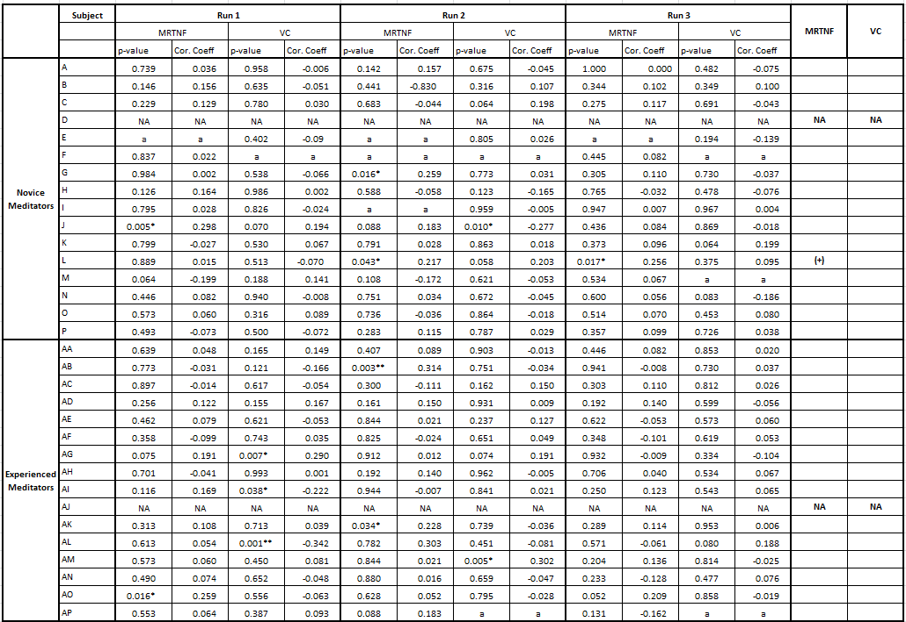

**Supplementary Table S13**

*Correlation coefficients between PCC time-series and occipital cortex control region for each meditation with real-time neurofeedback run (step iii) and volitional manipulation in the direction of effortless awareness run (step v).* (* p < 0.05, ** p < 0.005).



**Supplementary Table S14**

*Correlation coefficients between PCC time-series and left supplementary motor area control region for each meditation with real-time neurofeedback run (step iii) and volitional manipulation in the direction of effortless awareness run (step v).*



**Supplementary Table S15**

*Correlation coefficients between 40-57 Hz PCC time-series and 1-4 Hz (delta frequency band) PCC time-series for each meditation with real-time neurofeedback run (step iii).* (* p < 0.05, ** p < 0.005).



**Supplementary Table S16**

*Correlation coefficients between 40-57 Hz PCC time-series and 4-8 Hz (theta frequency band) PCC time-series for each meditation with real-time neurofeedback run (step iii).* (* p < 0.05, ** p < 0.005).



**Supplementary Table S17**

*Correlation coefficients between 40-57 Hz PCC time-series and 8-13 Hz (alpha frequency band) PCC time-series for each meditation with real-time neurofeedback run (step iii).* (* p < 0.05, ** p < 0.005).



**Supplementary Table S18**

*Correlation coefficients between 40-57 Hz PCC time-series and 13-30 Hz (beta frequency band) PCC time-series for each meditation with real-time neurofeedback run (step iii).* (* p < 0.05, ** p < 0.005).

